1. Grade Checker

Take a score as input and print the grade based on the following:

90+ : "A"

80-89 : "B"

70-79 : "C"

60-69 : "D"

Below 60 : "F"

here we used a basic if else statement to carry out marks and all.

* I have very good understanding of CPP and a bit of java too
* But seems like Python is not for me
* It’ll take time to grasp the basics still managed to code
* Am also trying to completely switch to python as its applications are too good

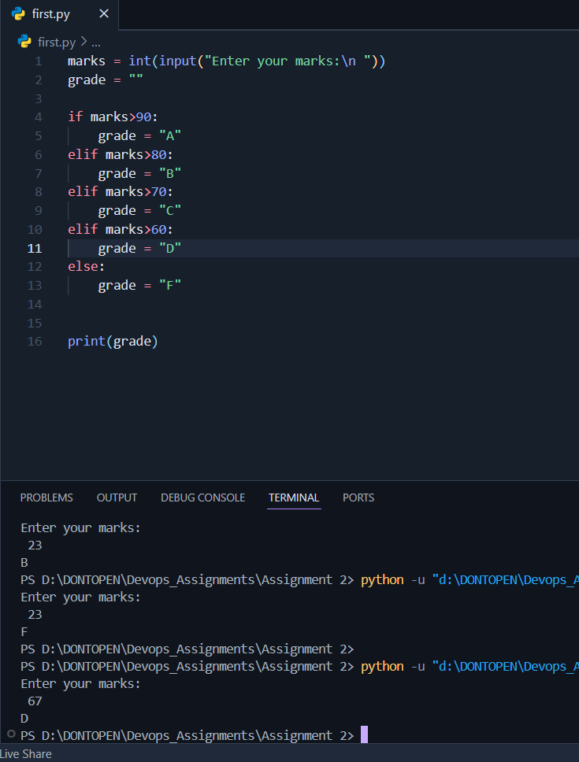

2 Student Grades

Create a dictionary where the keys are student names and the values are their grades. Allow the user to:

Add a new student and grade.

Update an existing student’s grade.

Print all student grades.

* To be honest its bit difficult for me I had quick peek on w3 school for more information over dictionary.
* **Problem: I didn’t get that (Allow the user to …) . I am the one who created the dictionary. Is there any access specification to this ? Like someone else going to access the dictionary.**

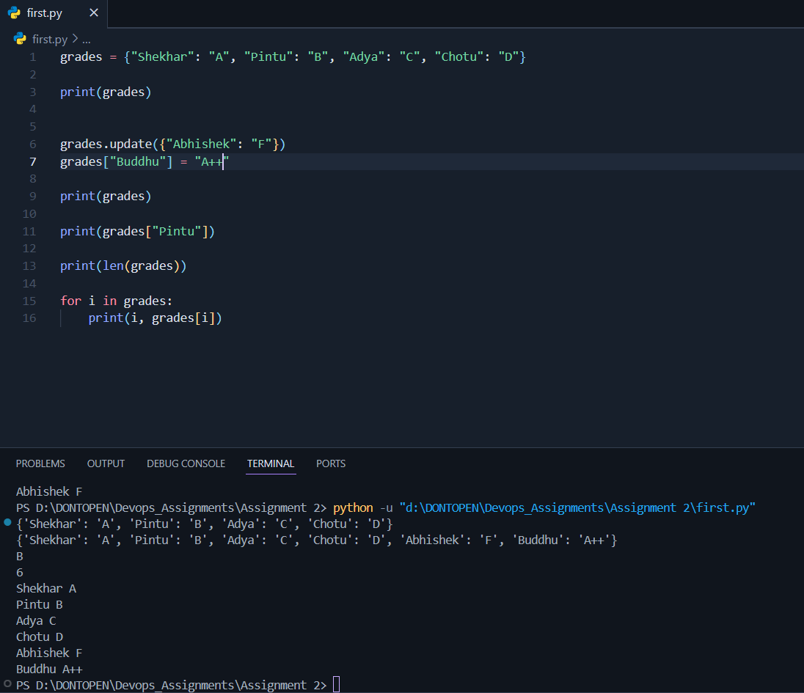

Used dictionary and basic operations. Using if else:

3.Write to a File

Write a program to create a text file and write some content to it.

Using file functions like write and open.

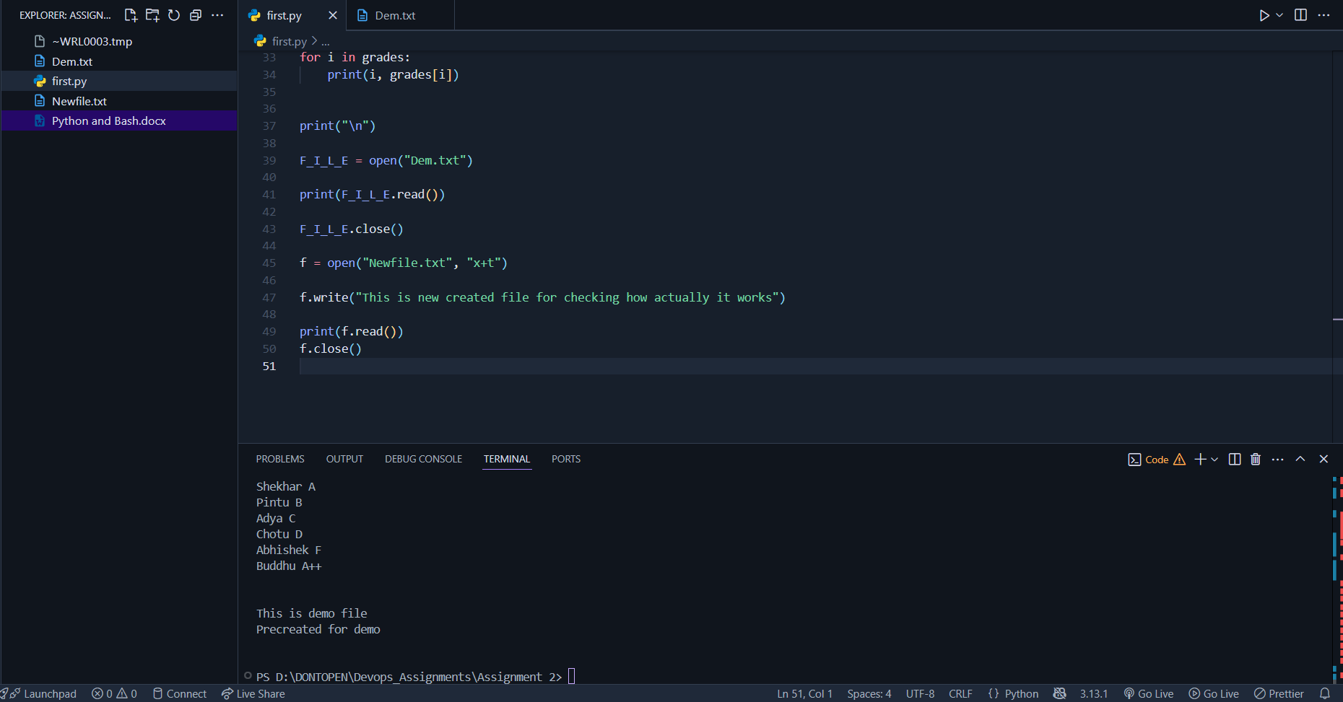

* I am so confused with all the permissions and file handling methods
* I think I have to explore more about these file handling commands
* Like x , x+t , xt+ , and there is so much to do..
* In above image ive first created a file manually without code wrote some content in it .
* Then created via code
* I had some problem the code was not working later on searching for a bit I got it.

4. Read from a File

We used open in read mode and file.read to read and print to display.

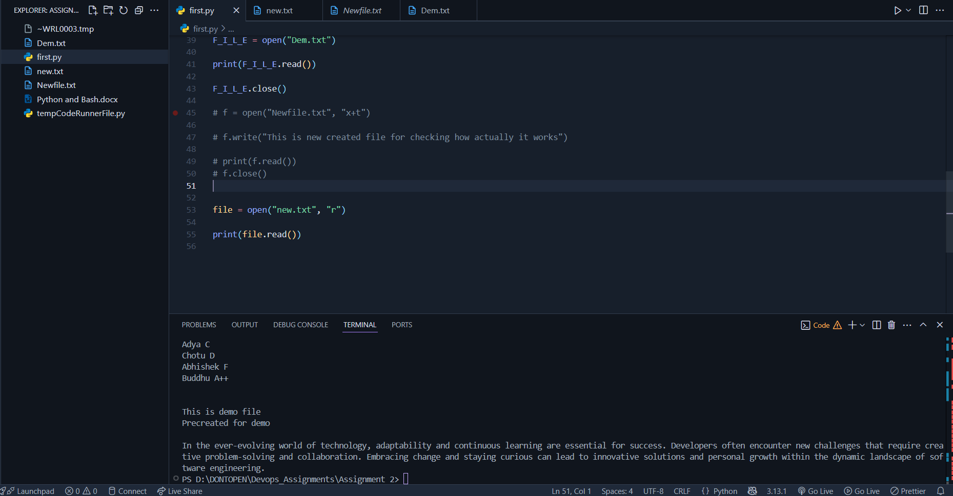

**Submission Guidelines -:** Attach Screenshots or command along with explanation and submit in doc(google doc or microsoft doc) format or share github link

[Upload files · shekhardase/TuteDude_Assignments_Devops](https://github.com/shekhardase/TuteDude_Assignments_Devops/upload/main)